**Abstract**

An Integrated Circuit tester (IC tester) is used to test Integrated Circuits (ICs). We can easily test any digital IC using this kind of an IC tester. For testing an IC, we need to use different hardware circuits for different ICs; like we need a particular kind of tester for testing a logic gate and another for testing flip flops or shift registers which involves more complication and time involved will also be more. So here’s an IC tester to overcome this problem. Unlike other IC testers, this is more reliable and easier since we don’t need to rig up different kind of circuits for different kind of ICs, each time we need to test them.

Unlike the IC testers available in the market today which are usually expensive, this IC tester is affordable and user-friendly. This IC tester is constructed using Arduino Mega (Atmega 1286) microcontroller along with a bluetooth module and a display unit. It can test digital ICs having 14 pins (7400 series). Since it is programmable, any number of ICs can be tested within the constraint of the memory available. This IC tester can be used to test a wide variety of ICs which includes simple logic gates and also sequential and combinational ICs like flip-flops, counters, shift registers etc. It is portable and easy to use.

The block diagram of the programmable digital IC tester is as shown in below. It consists of Arduino Mega (Atmega 1286), 14-pin ZIF IC socket, display unit, Test and Indentify buttons,Bluetooth Module (HC-05).

To test a particular digital IC, one needs to insert the IC into the ZIF IC socket and press the “INDENTIFY” button.The IC number and name gets displayed on the LCD display unit.

Then to test individual gates,one need to press the “ TEST” button. If all the gates of the IC are fine then the green LED’s will grow and if any of the gates is damaged then the red LED’s will glow.Individual status of each gate can be seen on LCD display.

**Hardware:**

1. **Display Unit:** To display the result and for interaction with the user an HD44780 Liquid Crystal Display is used. This is a 2 line LCD with 16 input pins.

Pin Specifications of HD44780 LCD:

• Pin 1, 2, 3: Used for controlling brightness contrast of the LCD and are connected to a 10K potentiometer as in Figure 2 with pin 3 as wiper.

• Pin 4: Register Select (RS) RS = 0 ; Select command register RS = 1; Select data register.

• Pin 5: Read/ Write (R/W) R/W = 0 ; Write R/W = 1 ; Read

• Pin 6: Enable (E): A high to low pulse is needed at this pin for the LCD to read its inputs

• Pin 7 to Pin 14: Data lines

• Pin 15: Vcc i.e. 5V, used for glowing the backlight.

• Pin 16: Ground i.e. 0V.

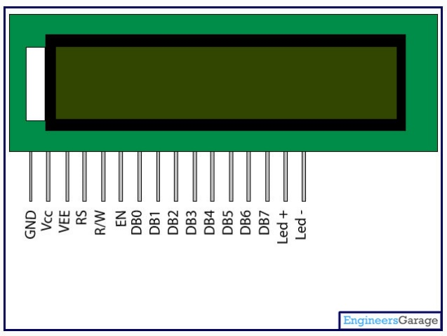

1. **Bluetooth Module (HC-05) :** To display the result on android application Bluetooth module is used.

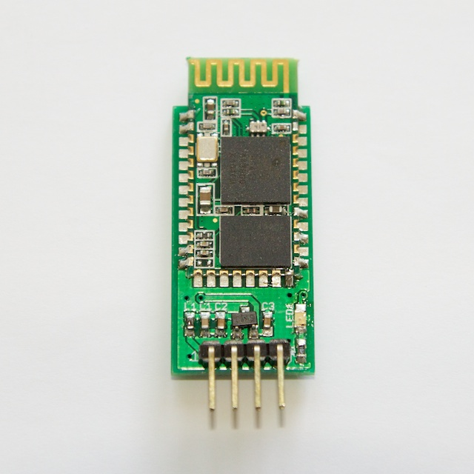

1. **Microcontroller :** The Arduino Mega is a microcontroller board based on the ATmega1280. It has 54 digital input/output pins (of which 14 can be used as PWM outputs), 16 analog inputs, 4 UARTs (hardware serial ports), a 16 MHz crystal oscillator, a USB connection, a power jack, an ICSP header, and a reset button. It contains everything needed to support the microcontroller; simply connect it to a computer with a USB cable or power it with a AC-to-DC adapter or battery to get started.

|  |  |
| --- | --- |
| Operating Voltage | 5V |
| Input Voltage (recommended) | 7-12V |
| Input Voltage (limits) | 6-20V |
| Digital I/O Pins | 54 (of which 15 provide PWM output) |
| Analog Input Pins | 16 |
| DC Current per I/O Pin | 40 mA |
| DC Current for 3.3V Pin | 50 mA |
| Flash Memory | 128 KB of which 4 KB used by bootloader |
| SRAM | 8 KB |
| EEPROM | 4 KB |
| Clock Speed | 16 MHz |

The ATmega1280 has 128 KB of flash memory for storing code (of which 4 KB is used for the bootloader), 8 KB of SRAM and 4 KB of EEPROM (which can be read and written with the [EEPROM library](http://www.arduino.cc/en/Reference/EEPROM)).

**Software :**

**PCB Layout**

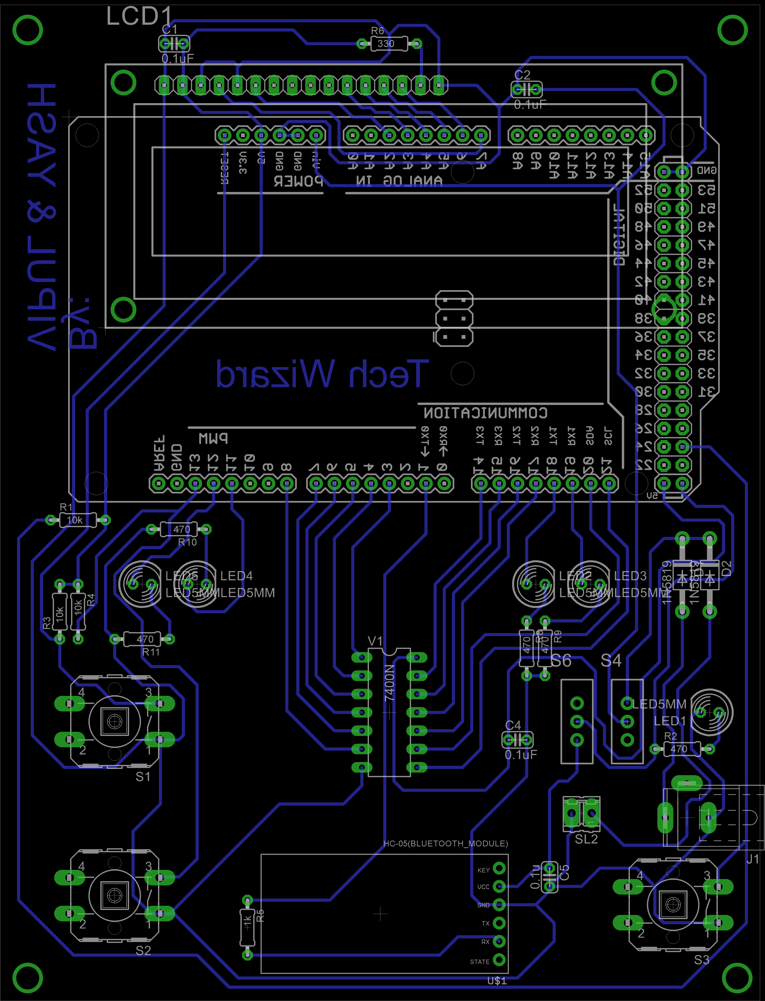

**Circuit Diagram**



**Block Diagram :-**

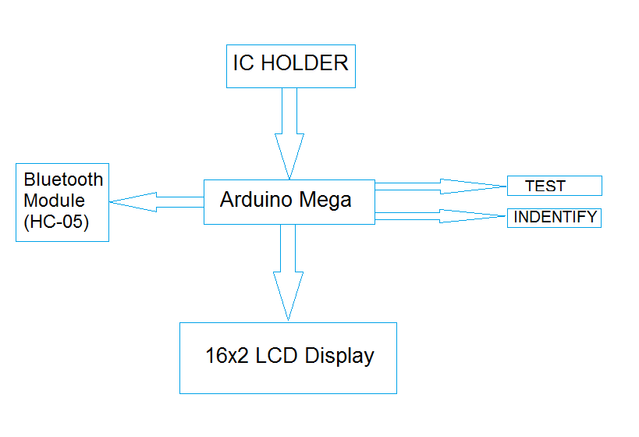

**Application:**

This is very useful for testing the digital logic IC’s as there are multiple gates in each ic and those are to be tested one at a time, and in some case we can have up to six gates, while in another case we may have IC which takes up to 3 input. So it is very painful and time consuming, it saves time and human effort for testing the IC. And it gives the result instantaneously.

**ICs THAT CAN BE TESTED**

* 7400- Quad 2-Input NAND Gate
* 7402-

**FUTURE EXTENSIONS**

This Integrated Circuit Tester is only programmed for the ICs of 7400 series. However, this device can be easily extended for a large no. of ICs as long as memory permits. No rewiring is required. Only editing the source code accordingly will be needed.